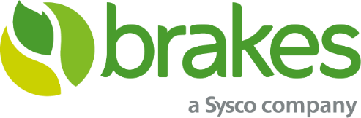

Please pass this on to anyone who may require the service.

Home delivery slots are hard to come by so this gives you another option.
Brakes at Hemsworth have two new services available to the public: home delivery and call and collect

Anyone living in and around the Hemsworth area can use it, it’s not just for businesses and there is no account to be set up either. The home delivery and call & collect services have been introduced as Brakes help to take some of the pressure off local supermarkets and you can buy bigger packs, and in bulk, reducing the number of shopping trips that you need to make, which supports government advice on minimising social contact

There are over 6,000 products including bread, flour, pasta, dairy, desserts, drinks, snacks, other store cupboard items, fish & seafood, meat & poultry, ready meals and fruit and veg boxes at great prices. You can now get the same products that chefs use, including home essentials and well-known brands.

To arrange a home delivery, visit www.brakesfoodshop.co.uk where you can browse the range of products. Place an order online anytime and choose your delivery day from those available. Brakes telesales will call you to take payment by card. There is a minimum order value of £75 and a maximum of £1000 with consumers limited to no more than ten packs of any one product.

See if you can get the home delivery by typing your postcode in here www.brakesfoodshop.co.uk otherwise you might be closer to picking it up from the depot Brakes Food Shop, Hemsworth, Hoyle Mill Road, Kinsley, Pontefract, WF9 5EB
#communityworkingtogether #inittogether

